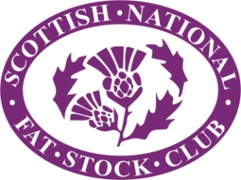
LiveScot
Lanark Agricultural Centre
Friday and Saturday 21st and 22nd November 2025

LiveScot 2025 brought Scotland’s agricultural community together for a vibrant showcase of livestock excellence, and industry collaboration. The event highlighted the progress and passion driving the sector, delivering a full schedule of standout livestock classes, hands-on displays, and valuable sector updates.

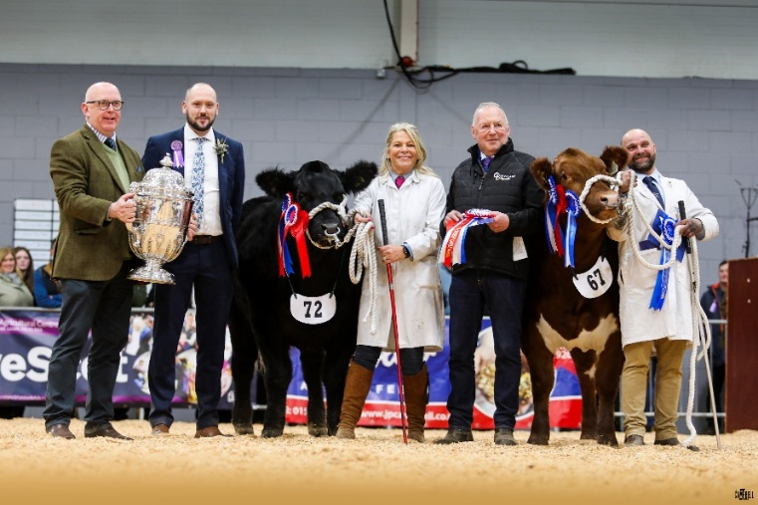
Taking the supreme among the cattle was Sassy Lady from Allan and Susan Campbell, Crawlaw, Galston.
This 674kg Limousin Cross heifer, was purchased out of Carlisle from EH Pennie and Son. She sold for £9500 in the sale ring when selling to John Scott Meats, Paisley.
Overall reserve went to the Pink Lady, a 666kg British Blue cross heifer from James Nisbet, Sorn Mains, which later made £8200 to Drumbeg Farms Ltd. Purchased out of Ireland from Martin McNeil.
Beth and Luke Wilkinson’s 660kg Limousin cross steer, Monty, lifted the housewives choice champion, and went on to realise £3600 to Bowland Foods Ltd.
From the unhaltered classes, the champion was a 700kg Limousin Cross heifer from Andrew Purdon and Partners, Stravenhouse, which made £3800 to Hugh Black and Sons.
Runner up was another Limousin Cross heifer, this one crossing the scales at 695kg for C Smith and son, which was purchased by B and T Kitson for £3300.
At the end of the day, 28 cattle cashed in at £2524.02 (+£913.74 on the year), 9 unhaltered cattle averaged £3077.62 (+£822.43)
This was followed by the 26 Lanarkshire Young Farmers’ calf rally entries, which averaged £3049.08 (+£995.80 on the year)
Overall champion went to a 644kg Limousin Cross heifer from Clare Miller, which went on to make £4000 to B and T Kitson.

The commercial calf champion went to a 400kg Limousin cross steer, The Crofter, from Andy Ireland, Braeside. Runner up and best bred by exhibitor was awarded to the 394kg Limousin cross heifer, Greenwells Hattie from Brian Harper; Greenwells.
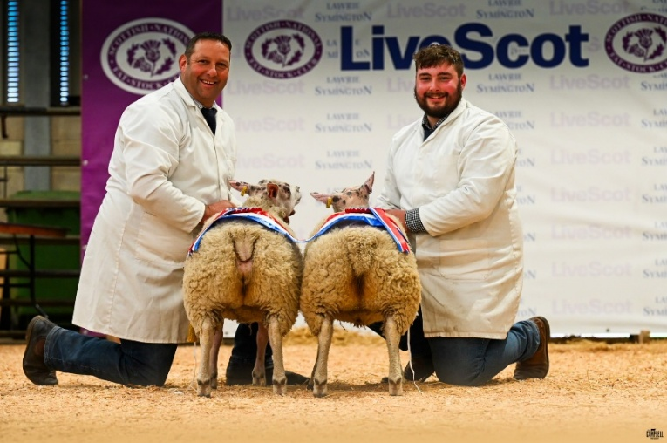
Among the sheep, Robert Garth and Sarah Priestley, Peaks View, secured the supreme with a pair of untrimmed Beltex cross lambs weighing 51kg. They later sold to the judge, Chris Timm, Timm family butchers, Pickering, for £500 per head.
Runners up were a pair of 51kg Texel lambs, from John Hall, Inglewood Edge, which went on to make £310 per head when also heading home with the judge.
The Hill champion pen, came in the form of 48kg Blackface duo from Andrew Reid, Glendearg, and sold for £350 per head to David Comrie and Son.
In total 96 lambs sold to average £184.69 per head (+£35.46 on the year)

On the Friday evening, the pedigree calf inter-breed was won by the British Blue heifer, Solway View Ultraviolet, from Kevin Watret, Maulcastle. Runner up went to the Beef Shorthorn heifer, Lairdmannoch Roxy Victoria from Meghan Carson; Lairdmannoch Estate.
It was the Limousin pairing - Bruce T Goldie; Townfoot - Goldies Vista and Stephen and Thomas Illingworth; Howgillside - Glenrock Versace – that took the inter-breed pairs, which was followed by the Charolais duo from Brailes Livestock; C/o Dyke Farm - Brailes Violet and Richard McCornick; Barnbackle farm - Ricnick Voodoo.

Along in the sheep lines, it was a Texel ewe lamb from Kenny O’Connor, Carstairs, that took the MV champion, which was closely followed by a Blue Texel ewe lamb from Kevin Watret, Maulcastle.
The non-MV section was won by a Mule ewe lamb from Gavin Donald, Strathaven, with the blue and white rosette going to a Bluefaced Leicester ewe lamb from A and A Kirkpatrick, Barr Farm.

The Smith family of New Greentowers Farm took the Dairy champion for the second consecutive year, this year’s winner was Wilsbro Lambda Frost 4255, which also won the best udder award.
Gavin Baillie, Crumhaugh, bagged the blue and white rosette and best bred by exhibitor with Dalserf Unix Finesse.

Our very own first sheep dressing competition was well supported and it was Joe Barker and Cameron Baillie that came out on top.
Andrew Purdon and Partners, Stravenhouse, did the double in the saddle of lamb and beef ribs competition.

Among the Native Pony Winter Fair, Aikengall Belhaven Boy from Emma Hamilton took the Highland Pony Championship and Harviestoun Drum from Eynhallow Shetland Pony Stud secured the Shetland Pony Supreme.

As part of our Rib Roast auction, we managed to raise a phenomenal £5260 for our two chosen charities this year, RASBI and MacMillan Nurses.

Cattle class results
Class 1 – Pure bred native bullock
1st – J & S Wareham; Little Tottingworth - Waughy (Galloway)
2nd – George McFadzean; Woodhead Of Mailer - Cherrybank (Aberdeen Angus)

Class 2 – Native cross bred bullock
1st – George McFadzean; Woodhead Of Mailer - Big Davie (Aberdeen Angus Cross)

Class 3 A – Continental bullock
1st – A & E Vance; Bridgehouse Farm - Mayhem (Limousin Cross)
2nd – Andy Ireland; Braeside - Pedro (Limousin Cross)
3rd – Wilson A Peters; Cuilt Farmhouse - Flash (Limousin Cross)

Class 3 B – Continental bullock
1st – B & L Wilkinson; Leyburn - Monte (Limousin Cross)
2nd – Wilodge; Lodge Hill farm - Bang On (Limousin Cross)
3rd – Blair Duffton; 2 Bogie Street - Mr Biggles (Limousin Cross)

Class 3 C – Continental bullock
1st – R & J Hamilton; Mid Shawtonhill Farm- Tyson (Limousin Cross)
2nd – James Kerr; Cloquhairnan Farm, Coylton - Bizby (Limousin Cross)
3rd – D McBeath and SJ Jessop; Lower Greenyards- Another Oop's (Limousin Cross)

Class 4 A – Native heifer
1st – Ian Tennant; Oldhill Farm - Black Diamond (Aberdeen Angus)
2nd – George McFadzean; Woodhead Of Mailer - Cherrybank (Aberdeen Angus)

Class 4 B – Native heifer
1st – C Smith and Son; North Boig (Beef Shorthorn
2nd – Andrew Ewing; Dumbretton - Belty Lass (Belted Galloway Cross)
3rd – Anderson & Blair; Littleinch Farmhouse - Atomic (Aberdeen Angus Cross)

Class 5 A – Continental heifer
1st – Mr & Mrs M Alford; Foxhill Farm- The Duchess (Limousin)
2nd – Blair Duffton; 2 Bogie Street - Special K (Limousin Cross)
3rd – Wilson A Peters; Cuilt Farmhouse - Bottoms Up (Limousin Cross)

Class 5 B – Continental heifer
1st – James Nisbet; Sorn Mains - Stardust (Brittish Blue)
2nd – Wilson A Peters; Cuilt Farmhouse - Poly Pucker Up (Limousin Cross)
3rd – JM & SM Priestley; Cracrop - Elektra (British Blue Cross)

Class 5 C – Continental heifer
1st – James Nisbet; Sorn Mains - Pink Lady (British Blue)
2nd – Wilodge; Lodge Hill - Bunny Boiler (British Blue Cross)
3rd – B & L Wilkinson; Leyburn - Maeve (Limousin Cross)

Class 5 D – Continental heifer
1st – Allan & Susan Campbell; Crawlaw - Sassy Lady (Limousin Cross)
2nd – Andy Ireland; Braeside - Rouge (Limousin Cross)
3rd – Dunlop; Holehouse - La Roux (Limousin)

Class 5 E – Continental heifer
1st – Wilson A Peters; Cuilt Farmhouse - Shelby Ggt (Limousin Cross)
2nd – Anderson & Blair; Littleinch Farmhouse - Lucky (Limousin Cross)
3rd – Andrew Ewing; Dumbretton - Jess (Limousin Cross)

Unhaltered cattle classes

Class 6 Steer
1st – Andrew Purdon and Partners, Stravenhouse (90)
2nd – C Smith and Son, North Boig (87)
3rd – Wilson Peters, Cuilt Farmhouse (89)

Class 7 Heifer
1st – Andrew Purdon and Partners, Stravenhouse (93)
2nd – C Smith and Son, North Boig (95)
3rd – Wilson Peters, Cuilt Farmhouse (97)

Champion Butchers Animal (R B Meiklejohn Challenge Trophy) – Andrew Purdon and Partners, Stravenhouse (93)
Reserve Champion: C Smith and Son, North Boig (95)
Best Animal Opposite Sex to the Champion (D M Brown Challenge Trophy): Andrew Purdon and Partners, Stravenhouse (90)
Heaviest Butchers Animal (R Russell Trophy): C Smith and Son, North Boig (88)

Commercial Calf Class Results

Class 8A – Heifer Calf born on or after 1st January 2025
1st – R & J Hamilton; Mid Shawtonhill - Hot Stuff (British Blue Cross)
2nd – R & J Hamilton; Mid Shawtonhill - Bonnie Blue (Limousin Cross)
3rd – Stewart and Lynsey Bett; Boquhan Home - Dazzler (Limousin Cross)

Class 8B – Heifer Calf born on or after 1st January 2025
1st – Brian Harper; Greenwells - Greenwells Hattie (Limousin Cross)
2nd – A MacGregor; Allanfauld - Aurora (Limousin)
3rd – Allan & Susan Campbell; Crawlaw - Starburst (Limousin Cross)

Class 9A – Steer Calf born on or after 1st January 2025
1st – Andy Ireland; Braeside - The Crofter (Limousin Cross)
2nd – J & S Wareham; Little Tottingworth - Bandit (Galloway Cross)
3rd – Jean Mackay; Auchenairney - Mufasa (Limousin Cross)

Overall Champion Calf: Andy Ireland; Braeside - The Crofter (Limousin Cross)
Reserve Champion: Brian Harper; Greenwells - Greenwells Hattie (Limousin Cross)
Best bred by exhibitor: Brian Harper; Greenwells - Greenwells Hattie (Limousin Cross)

CATTLE CHAMPIONSHIPS
(order of judging – Championships)

Housewives choice: B and L Wilkinson, Leyburn with the Limousin cross bullock, Monte

Light Steer: Champion: Drever & Work; Mains of Dumbreck - Hunky Dory (Limousin Cross)
Reserve: Shona Stevenson; Carbello Farm - Tango (Limousin Cross)

Heavy Steer: Champion: B & L Wilkinson; Leyburn - Monte (Limousin Cross)
Reserve: A & E Vance; Bridgehouse Farm - Mayhem (Limousin Cross)

Champion Steer: Champion: B & L Wilkinson; Leyburn - Monte (Limousin Cross)
Reserve: A & E Vance; Bridgehouse Farm - Mayhem (Limousin Cross)

Light Heifer: Champion: Mr & Mrs M Alford; Foxhill Farm- The Duchess (Limousin)
Reserve: Blair Duffton; 2 Bogie Street - Special K (Limousin Cross)

Heavy Heifer: Champion: Allan & Susan Campbell; Crawlaw - Sassy Lady (Limousin Cross)
Reserve: James Nisbet; Sorn Mains - Pink Lady (Brittish Blue)

Champion Heifer: Champion: Allan & Susan Campbell; Crawlaw - Sassy Lady (Limousin Cross)
Reserve: James Nisbet; Sorn Mains - Pink Lady (Brittish Blue)

Supreme Champion: Allan & Susan Campbell; Crawlaw - Sassy Lady (Limousin Cross)
Reserve: James Nisbet; Sorn Mains - Pink Lady (Brittish Blue)

Best Lightweight: Champion: Mr & Mrs M Alford; Foxhill Farm- The Duchess (Limousin)
Reserve: Blair Duffton; 2 Bogie Street - Special K (Limousin Cross)

Best Heavyweight: Champion: Allan & Susan Campbell; Crawlaw - Sassy Lady (Limousin Cross)
Reserve: James Nisbet; Sorn Mains - Pink Lady (British Blue)

Best Pure AA: Ian Tennant; Oldhill Farm - Black Diamond (Aberdeen Angus)

Best Pure Galloway: J & S Wareham; Little Tottingworth - Waughy (Galloway)

Best Shorthorn heifer: C Smith and Son; North Boig (Beef Shorthorn)

Best Pure Native and overall pure bred: J & S Wareham; Little Tottingworth - Waughy (Galloway)

Best Pure Bred non indigenous: Hodges livestock; Dykes - Hodges Valliant (Charolais)

Breeder of best Animal: E H Pennie & Son

Best Bred by Exhibitor: B & L Wilkinson; Leyburn - Monte (Limousin Cross

Best Pair: Wilson Peters

Best Cross: Allan & Susan Campbell; Crawlaw - Sassy Lady (Limousin Cross)

SHEEP
Sheep Class Results

Class 18 - Untrimmed pen of two lambs progeny of a native sire
1st - Messrs M Stewart

Class 19 - Untrimmed pen of two lambs, progeny of a continental sire
1st - R Garth & S Priestley
2nd - R & M Struthers
3rd - R Hall & Son

Class 20 - pen of two lambs, progeny of a Suffolk or Native downland sire
1st - R Hall & Son
2nd - R Garth & S Priestley
3rd - Messrs M Stewart

Class 21 - pen of two lambs, progeny of a Texel sire (not exceeding 84kg)
1st - R Hall & Son
2nd - WW & M Cuthbertson

Class 22 - pen of two lambs, progeny of a Texel sire (over 84kg)
1st - R Hall & Son
2nd - J Orr & Partners
3rd - R & M Struthers

Class 23 - pen of two lambs, progeny of a Beltex sire (not exceeding 84kg)
1st - R Hall & Son
2nd - Messrs M Stewart
3rd - R West

Class 24 - pen of two lambs, progeny of a Beltex sire (over 84kg)
1st - R Hall & Son
2nd - Messrs M Stewart
3rd - R Garth & S Priestley

Class 25 - pen of two lambs, progeny of. Dutch spotted sire
1st - J Marshall
2nd - J Marshall

Class 27 - pen of two lambs, progeny of any other continental sire
1st - R West
2nd - R Garth & S Priestley
3rd - J Currie

Class 28 - pen of two lambs, any breed or cross to be shown by young breeders
1st - April Skelton
2nd - Cameron & Rachel Baillie
3rd - Libby & Rosie Garth

Class 11 - Blackface Pure Bred, pen of two lambs (not exceeding 80kg)
1st - R & B Dickie
2nd - R & B Dickie
3rd - AJ Kennedy & Son

Class 12 - Blackface Pure Bred, pen of two lambs (over 80kg- not exceeding 88kg)
1st - Andrew Reid
2nd - AJ Kennedy & Son
3rd - Firm of Shawhead

Class 13 - Blackface Pure Bred, pen of two lambs (over 88kg)
1st - Andrew Reid
2nd - J J Frame & Co
3rd - R & B Dickie

Class 14 - North Country Cheviot , pen of two lambs (any weight)
1st - SRUC Barony
2nd - Andrew Purdon & Parts
3rd - R & J Andrews

Class 15 - South Country Cheviot, pen of two lambs (any weight)
1st - Alan Frame
2nd- Andrew Reid
3rd - Firm of Shawhead

Class 16 - Mule & Crosses , pen of two lambs (progeny of a Leicester ram and Blackface or Cheviot ewe)
1st - H Cockburn & Partners
2nd- C & F Frame
3rd -Firm of Shawhead

Class 17 - Mule & Crosses , pen of two lambs (progeny of a Leicester ram and Swaledale or Northumberland Blackface ewe)
1st - H Cockburn & Partners

Class YH4 – Best handler up to and including 12
1st - Sarah Purdon
2nd - William Ferrie
3rd - Andrew Purdon
4th – Lauren Baillie
5th – Archie Baillie
6th – Robin Dunlop

Class YH5 – Best young handler between 13 and 17
1st – Rosie Garth
2nd – Lewis O’Connor
3rd – Ben Baillie
4th – Stuart McLeod
5th – Murray Clark

Champion Young Handler (Walkerdyke Cup): Rosie Garth

Overall Sheep
Champion Blackface – A Reid, Glendearg
Reserve Champion Blackface – R & B Dickie, Spango

Champion North Country Cheviot – SRUC Barony
Reserve Champion North Country Cheviot – Andrew Purdon and Partners, Stravenhouse

Champion South Country Cheviot – Alan Frame, High Dykes
Reserve Champion South Country Cheviot – Andrew Reid, Glendearg

Champion Mules & Crosses – H Cockburn & Parts, Kingside
Reserve Champion Mules & Cross – C & F Frame, Hawthornbank

Champion Butchers Lambs – R Garth & S Priestley, Peaks View
Reserve Champion Butchers Lambs – R Hall & Sons, Inglewood Edge

Champion Young Breeders Lambs – April Skelton
Reserve Champion Young Breeders Lambs – Cameron & Rachel Baillie

Champion Hill lambs – A Reid, Glendearg
Reserve Hill lambs – SRUC Barony (NCC)

Best Pen of Sheep in the Cheviot Sections - SRUC Barony

Texel Champion – R Hall and Sons, Inglewood Edge

Beltex Champion – R Garth & S Priestley, Peaks View

Native Champion – A Reid, Glendearg

Thorley shield (For the best pure bred or cross bred animal by a native sire) - A Reid, Glendearg

Tommy Macpherson memorial shield (most points in Blackface Section) - A Reid, Glendearg

Overall Sheep Champion – R Garth & S Priestley (untrimmed continental)
Overall Reserve Sheep Champion – R Hall & Sons (Texels over 84kg)

PEDIGREE CALVES

Galloway

Class 1000 Bull born between 1st July 2024 and 31st December 2024

1st - Messrs Wallace; Hannaston - I-Spy Of Over Barskeoch

Class 1002 Heifer born between 1st July 2024 and 31st December 2024

1st - Messrs Wallace; Hannaston - Issy Wkd Of Over Barskeoch

2nd - D & L Watret; Muirfield - Criffelview Rosie

3rd - Messrs Wallace; Hannaston - Hannaston Inca Rose

Champion - Messrs Wallace; Hannaston - I-Spy Of Over Barskeoch
Reserve - Messrs Wallace; Hannaston - Issy Wkd Of Over Barskeoch

Aberdeen-Angus

Class 1004 Bull born between 1st July 2024 and 31st December 2024

1st - Brailes Livestock; C/o Dyke Farm - Brailes Black Boy A 360

2nd - Donald Rankin; Kilmaluag House - Kilmaluag Ronaldo A401

3rd - Donald Rankin; Kilmaluag House - Kilmaluag Rivelino A400

Class 1005 Bull born after 1st of January 2025

1st - R & C Rettie; Dyke Farm - Retties Looney Tunes B363

2nd - Andrew Thomson; South Carse of Coldoch Farm - Coldoch Kelso B402

3rd – Mr & Mrs M Alford; Foxhill Farm - Foxhill Prince Evolution B192

Class 1006 Heifer born between 1st July 2024 and 31st December 2024
1st - R & C Rettie & Jamie Rettie; Dyke Farm - Brailes Lady Ruth A359

Class 1007 Heifer born after 1st of January 2025

1st - R & C Rettie; Dyke Farm - Retties Laura B374

2nd - R & C Rettie; Dyke Farm - Retties Lady Ruth B362

3rd - Caroline Morton; Low Merryton Farm - Keirsbeath Black Belle B002

Champion- R & C Rettie; Dyke Farm - Retties Looney Tunes B363

Reserve - R & C Rettie; Dyke Farm - Retties Laura B374

Beef Shorthorn
Class 1008 Bull born between 1st July 2024 and 31st December 2024
1st - Mrs L Townsend; Coxhill Farm - Coxhill Vancouver

Class 1009 Bull born after 1st of January 2025
1st - Cameron Wilson; New bogside - The Sheep Game Wilson
2nd - Natalie Hynd - Welbeck William
3rd - J Wightman & E McAlister; Coxhill - Islahill Windsor

Class 1010 Heifer born between 1st July 2024 and 31st December 2024
1st - Meghan Carson; Lairdmannoch Estate - Lairdmannoch Roxy Victoria
2nd - R & C Rettie; Dyke Farm - Aberdona Vanity Fair
3rd - Dr RJ Steen; Coxhill Farm - Hazelbank Lovely V077

Class 1011 Heifer born after 1st of January 2025
1st - J Wightman & E McAlister; Coxhill Farm - Islahill Wispa
2nd - James W Frame; Little Galla - Galla Willow Butterwort
3rd - Brenda R Wear; Hilltop - Redhill Sprys Lily 004
Champion - Meghan Carson; Lairdmannoch Estate - Lairdmannoch Roxy Victoria
Reserve - Mrs L Townsend; Coxhill Farm - Coxhill Vancouver

Highland
Class 1012 Bull born between 1st January 2024 and 31st December 2024

1st - Grant Hyslop; Glentewing Farm - Fear Á Ghlinne Of Black Glen

2nd - Bannockburn Highlanders; Snabhead West Farm - Bruce Of Bannockburn

Class 1013 Bull born after 1st of January 2025

1st - Coul Estate Partnership; Coul Estate - Seumus Dubh 1St Of Coul

2nd - Thomas & Harris Sloan; The coach house Netherurd - 600198 Of Hunters

Class 1014 Heifer born between 1st January 2024 and 31st December 2024

1st - Bannockburn Highlanders; Snabhead West Farm - Sorcha Of Mohmar

2nd - Stephen and Rosemary Hunter; Barnhill Farm - Frith Of Hunters

3rd - Thomas Sloan; The coach house Netherurd - Samhradh Of Brucefield

Class 1015 Heifer born after 1st of January 2025

1st - Coul Estate Partnership; Coul Estate - Molly 1St Of Coul

2nd - Stephen and Rosemary Hunter; Barnhill Farm - Frith 2Nd Of Hunters

3rd - Stephen and Rosemary Hunter; Barnhill Farm - Capleadh 7Th Of Hunters
Champion - Grant Hyslop; Glentewing Farm - Fear Á Ghlinne Of Black Glen

Reserve - Coul Estate Partnership; Coul Estate - Molly 1St Of Coul

Hereford
Class 1017 Bull born after 1st of January 2025

1st - Daniel Holmes; Back O' Hill Farm - Moralee 1 Casino Pr395

Class 1019 Heifer born after 1st of January 2025

1st - Brenda R Wear; Hilltop, Windover Farm - Garnet 1 Eira

2nd - Daniel Holmes; Back O' Hill Farm - Back O Hill Spark

Champion: Daniel Holmes; Back O' Hill Farm - Moralee 1 Casino Pr395
Reserve: Brenda R Wear; Hilltop, Windover Farm - Garnet 1 Eira 008

Belted Galloway
Class 1020 Bull born between 1st July 2024 and 31st December 2024

1st - Allan & Susan Campbell; Crawlaw Farm - Crawlaw Harris

Class 1021 Bull born after 1st of January 2025

1st - Mervyn Forster; Elgany Farms C/o Dyke Farm - Elgany Willard

Class 1023 Heifer born after 1st of January 2025

1st - Allan & Susan Campbell; Crawlaw Farm, Galston - Crawlaw Rona

Champion - Mervyn Forster; Elgany Farms C/o Dyke Farm - Elgany Willard
Reserve - Allan & Susan Campbell; Crawlaw Farm, Galston - Crawlaw Rona

Limousin
Class 1024 Bull born between 1st July 2024 and 31st December 2024

1st - Bruce T Goldie; Townfoot - Goldies Vista

2nd - R and J Graham; Boquhan Home Farm - Graham's Virgil

3rd - R and J Graham; Boquhan Home - Graham's Verrier

Class 1025 Bull born after 1st of January 2025
1st - Mr & Mrs M Alford; Foxhill Farm - Foxhillfarm Alberto

Class 1026 Heifer born between 1st July 2024 and 31st December 2024

1st - Mr S & Mr T Illingworth; Howgillside - Glenrock Versace

2nd - D McBeath and SJ Jessop- Springsett Valentina

3rd - Ian & Andrew Nimmo; Bogside Farm - Maraiscote Voxanne

Class 1027 Heifer born after 1st of January 2025

1st - R and J Graham; Boquhan Home Farm - Graham's Aria

2nd - D McBeath and SJ Jessop; Lower Greenyards Farm - Springsett Aquamrine

3rd - D & L Graham, Mains of Burnbank - Burnbank Ainsi
Champion: Bruce T Goldie; Townfoot - Goldies Vista
Reserve: Mr S & Mr T Illingworth; Howgillside - Glenrock Versace

British Blue
Class 1028 Bull born between 1st July 2024 and 31st December 2024

1st - Kevin Watret; Maulscastle Farm - Solway View Unionjack

2nd - Ian McGarva; Nether Abington Farm - Abington Unit

3rd - A & CS Comrie; Stonebyres Mains - Stonebyres Universe

Class 1029 Bull born after 1st of January 2025

1st - Jean Mackay; Auchenairney Farm - Harelaw Victor

2nd - Gavin Scott; Gateside Farm - Thistle Vimto

3rd - Kevin Watret; Maulscastle Farm - Solway View Vinnie

Class 1030 Heifer born between 1st July 2024 and 31st December 2024

1st - Kevin Watret; Maulscastle Farm - Solway View Ultraviolet

2nd - P & K Brannen; Scartop - Moorsley Unique

3rd - A & CS Comrie; Stonebyres Mains Farm - Stonebyres Urchin

Class 1031 Heifer born after 1st of January 2025

1st - Jean Mackay; Auchenairney Farm - Harelaw Vanessa

2nd - Kevin Watret; Maulscastle Farm - Solway View Valentine

3rd - R & J Hamilton; Mid Shawtonhill - Shawtonhill Valentine

Champion: Kevin Watret; Maulscastle Farm - Solway View Ultraviolet
Reserve: Jean Mackay; Auchenairney Farm - Harelaw Vanessa

Charolais

Class 1032 Bull born between 1st July 2024 and 31st December 2024

1st - A McCornick and Co; Barnbackle farm - Ricnick Voodoo

2nd - J & E Wight; Townfoot Farm- Midlock Vagabond

Class 1033 Bull born after 1st of January 2025

1st - J & E Wight; Townfoot Farm - Midshield Aceman

Class 1034 Heifer born between 1st July 2024 and 31st December 2024

1st - Brailes Livestock; C/o Dyke Farm - Brailes Violet

2nd - J & E Wight; Townfoot Farm - Midlock Val

3rd - J & E Wight; Townfoot Farm - Midlock Venice

Class 1035 Heifer born after 1st of January 2025

1st - Kevin Watret; Maulscastle Farm - Annanview Ambrose

2nd - Brailes Livestock; C/o Dyke Farm - Brailes Amelia

Champion: Brailes Livestock; C/o Dyke Farm - Brailes Violet
Reserve: A McCornick and Co; Barnbackle farm - Ricnick Voodoo

Simmentals

Class 1036 Bull born between 1st July 2024 and 31st December 2024

1st - J &E Dyet; East Merkland Farm - Merkland Rory

2nd - J &E Dyet; East Merkland Farm - Merkland Rocket

Class 1037 Bull born after 1st of January 2025

1st - Delfur Farms; Dundurcas Farm- Delfur Super Nova

2nd - Gavin Brown; Springfield - Springfield Strongbow

Class 1038 Heifer born between 1st July 2024 and 31st December 2024

1st - Gavin Brown; Springfield- Springfield Rose

2nd - Delfur Farms; Dundurcas Farm- Aultside Royalty

3rd - Frank Gwynne; Castlewigg Farm - Chestermann Explorer Lulu 4

Class 1039 Heifer born after 1st of January 2025

1st - Delfur Farms; Dundurcas Farm- Delfur Shakira

2nd - Frank Gwynne; Castlewigg Farm - Castlewigg Ringleader J-Lo 2

3rd - Gavin Brown; Springfield - Springfield Skylar

Champion - Delfur Farms; Dundurcas Farm- Delfur Super Nova

Reserve - Delfur Farms; Dundurcas Farm- Delfur Shakira

INTER-BREED

Champion: Kevin Watret; Maulscastle Farm - Solway View Ultraviolet (British Blue)

Reserve: Meghan Carson; Lairdmannoch Estate - Lairdmannoch Roxy Victoria (Beef Shorthorn)

Pairs: Limousin - Bruce T Goldie; Townfoot - Goldies Vista and S & T Illingworth; Howgillside - Glenrock Versace
Reserve: Charolais - Brailes Livestock; C/o Dyke Farm - Brailes Violet and A McCornick and Co; Barnbackle farm - Ricnick Voodoo
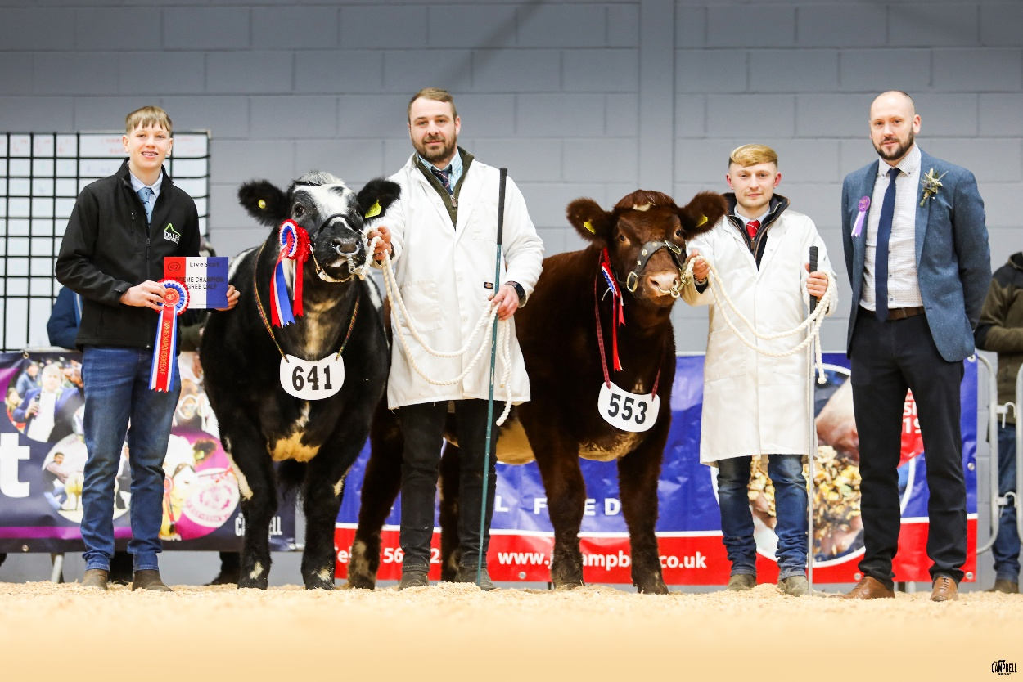

Cattle Young Handlers

Class: YH 1 (age 12-15 years old)
1st – Cameron Harrison
2nd – Lily Smith
3rd – Olly Paterson

Class: YH 2 (age 16-18 years old)
1st – Ruby Smith
2nd – Thomas Goldie
3rd – Finlay Hunter

PEDIGREE LAMBS
MV Accredited

TEXEL

Class 1044 Ewe lamb

1st - TA and R Laird, Cambwell

2nd – TA and R Laird, Cambwell

3rd – R and M Struthers, Collielaw

Class 1045 Tup lamb

1st - K O’Connor, Carstairs

2nd – TA and R Laird, Cambwell

3rd – M and G Ballantyne, East Cauldcoats

BELTEX

Class 1046 Ewe lamb

1st - J and D Hodge, Dykes Farm

2nd – A Baillie, Carstairs Mains

3rd – K O’Connor, Carstairs

Class 1047 Tup lamb

1st - R and J Hamilton, Mid Shawtonhill

2nd – E Sanderson, Biggarshiels Mains

3rd – N Laing, Thankerton

DUTCH SPOTTED

Class 1048 Ewe lamb

1st - J and H Paterson, Cargenbridge

2nd – A McKerrow, Riverview House

3rd – A McKerrow, Riverview House

Class 1049 Tup lamb

1st - R and J Hamilton and W Baird, Mid Shawtonhill

2nd – J Marshall, Struie Dutch Spotted

3rd – J Marshall, Struie Dutch Spotted

ANY OTHER CONTINENTAL BREED MV ACCREDITED ONLY

Class 1050 Ewe lamb

1st - K Watret, Maulcastle

ANY OTHER NATIVE BREED MV ACCREDITED ONLY

Class 1052 Ewe lamb

1st - A Jackson, Maulcastle

2nd – K Ramsay, Carstairs

3rd – J and D Hodge, Dykes Farm

MV CHAMPION: K O’Connor, Carstairs with Texel Tup Lamb

MV RESERVE: Kevin Watret, Maulcastle with Any Other Continental Ewe Lamb
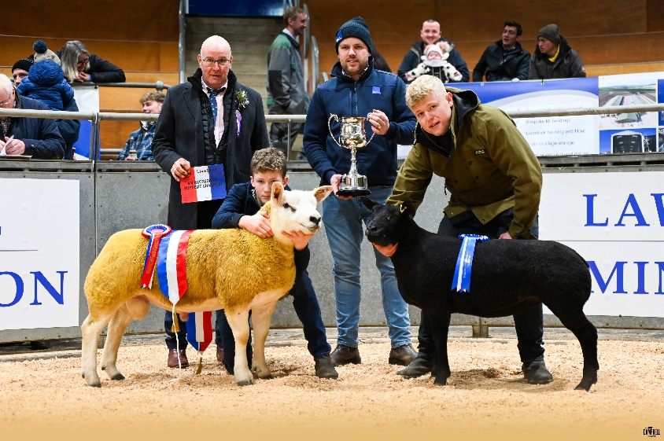

Non- MV Accredited

BLACKFACE

Class 1054 Ewe lamb

1st - Firm of Shawhead

2nd – J and A Boswell, Burnhead

3rd – Firm of Shawhead

Class 1055 Tup lamb

1st - Firm of Shawhead

2nd – Firm of Shawhead

3rd – G and S Donald, Strathaven

BLUEFACED LEICESTER

Class 1056 Ewe lamb

1st - A and A Kirkpatrick, Barr Farm

2nd – David Bryson, Grassmillees Way

3rd – A and A Kirkpatrick, Barr Farm

Class 1057 Tup lamb

1st - A and A Kirkpatrick, Barr Farm

2nd – David Bryson, Grassmillees Way

3rd – David Bryson, Grassmillees Way

MULE
Class 1058 Ewe lamb

1st - G and S Donald, Strathaven

2nd – G and S Donald, Strathaven

3rd – George W Allan, Ochiltree

ANY OTHER BREED NATIVE NON-MV ACCREDITED
Class 1061 Ewe lamb

1st - G and S Donald, Strathaven (SCC)

ANY OTHER BREED NATIVE NON-MV ACCREDITED
Class 1062 Ewe lamb

1st - G and S Donald, Strathaven (SCC)

NON - MV CHAMPION: G and S Donald with Mule ewe lamb

NON - MV RESERVE: A and A Kirkpatrick with Bluefaced Leicester ewe lamb

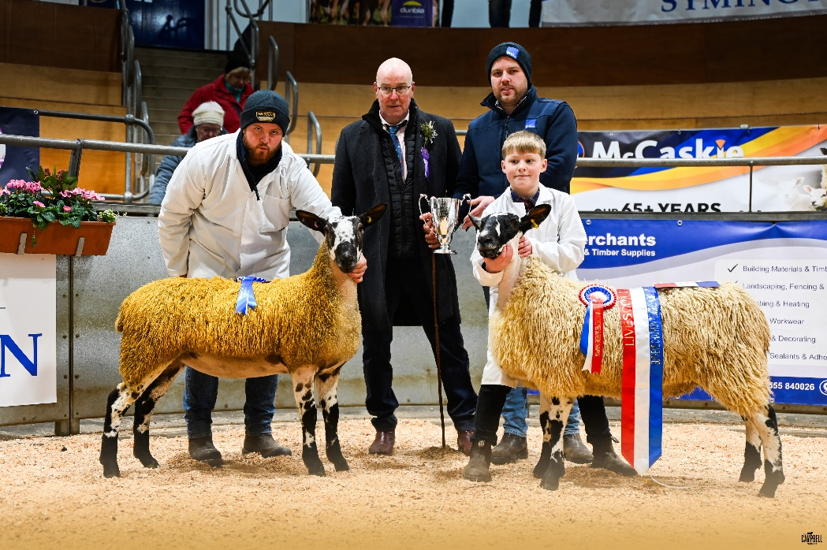

DAIRY

Class 28 – Heifer in Milk
1st – Donald Laird; The Murrays Farm - Cauldcoats Chief Peggy 2
2nd – J D Baillie; Crumhaugh - Dalserf Chief Amelia 5
3rd – Donald Laird; The Murrays Farm - Glenallan Lambda Camilla

Class 29 – Junior Cow in Milk
1st – I A Smith and sons; New Greentowers Farm – Wilsbro Lambda Frost 4255
2nd – J D Baillie; Crumhaugh - Dalserf Kingmaster Erle
3rd – A & E Lawrie; Grangehall Farm - Grangehall Improbable Papoose

Class 30 – Senior Cow in Milk
1st – J D Baillie; Crumhaugh - Dalserf Unix Finesse
2nd – I A Smith and sons; New Greentowers Farm - Boclair Lambda Royalty 2
3rd – Jim Boyd; Lettrickhills Farm - Lettrickhills Casper Rose

Overall Champion: I A Smith and sons; New Greentowers Farm - Wilsbro Lambda Frost 4255
Reserve Champion: J D Baillie; Crumhaugh - Dalserf Unix Finesse
Honourable mention: Donald Laird; The Murrays Farm - Cauldcoats Chief Peggy 2
Best Udder: I A Smith and sons; New Greentowers Farm - Wilsbro Lambda Frost 4255
Best Bred by Exhibitor: J D Baillie; Crumhaugh - Dalserf Unix Finesse

SHEEP DRESSING

Juniors (16 and under)
1st – Cameron and Finlay Barclay
2nd – Lewis O'Connor and Finlay Clark
3rd – Ben Baillie and Blair Nimmo

Seniors (16 to 26)
1st – Joe Barker and Cameron Baillie
2nd – Ben Graham and Ryan Adamson
3rd – Robbie and Katie Aitken

Overall Champion: Joe Barker and Cameron Baillie.
Reserve: Ben Graham and Ryan Adamson

GRAIN, SILAGE & HAY

Best Exhibit in the Grain Section: Wheat – Robert Robb Woodhead of Aberdalgie
Best Exhibit in the Grass & Silage Section: Grasss Silage – Lilburn Estate
Best Exhibit in the Junior Grain Section: Lily Smith, Sunnyhill Farms

Cass 32 – Barley: any spring variety
1st – Ryan Nelson, Blair Mains Farm
2nd – Robert Robb, Woodhead of Aberdalgie
3rd – Richard Nelson, Cuttlehill

Class 33 – Barley: any winter variety
1st – Robert Robb, Woodhead of Aberdalgie
2nd – Ryan Nelson, Blair Mains Farm
3rd – Richard Nelson, Cuttlehill

Class 34 – Oats: any variety
1st – Ryan Nelson, Blair Mains Farm
2nd – Richard Nelson, Cuttlehill

Class 36 – Grass silage: wrapped
1st – Robert Robb, Woodhead of Aberdalgie
2nd – Richard Nelson, Cuttlehill

Class 37 – Grass silage: approx. 2 kg
1st – Laird, St Clements Wells
2nd – Michael Aitken, Scotstoun Bank
3rd – Andrew Baird, Auchnotroch

Class 38 – Cereeal Whole crop Silage
1st – Richard Nelson, Cuttlehill
2nd – Gregor and Sam Vance, Bridgehouse

Class 39 – Hay
1st – W & S Thomson, Bordlands
2nd – Andrew Dunlop, Corstane
3rd – Ryan Nelson, Blair Mains Farm

Juniors

Class 40 – Barley – any winter variety
1st – Lily Smith, Sunnyhill Farms

BEEF RIB & SADDLE OF LAMB COMP

Class 101 – Continental Rib
1st – Gavin Paterson 169.7kg Limousin Cross
2nd – Tom King 168kg Limousin Cross
3rd – Andrew Purdon and Partners 176.2kg Limousin

Class 102 – Native Rib
1st – Andrew Purdon and Partners 163.1kg Aberdeen Angus
2nd – George Mcfadzean 178.4kg Aberdeen Angus Cross
3rd – Matthew Currie 201.5kg Aberdeen Angus

Class 103 – Saddle (light)
1st - George Whyte 23.3kg
2nd - George Whyte 22.7kg
3rd - Andrew Dunlop 23.2kg

Class 104 – Saddle (heavy)
1st - Andrew Purdon and Partners 26.5kg
2nd - Andrew Purdon and Partners 26.7kg
3rd - Andrew Dunlop 29.1kg

Champion Beef Rib: Andrew Purdon and Partners 163.1kg Aberdeen Angus
Reserve Champion Beef Rib: Gavin Paterson 169.7kg Limousin Cross

Champion Saddle of Lamb: Andrew Purdon and Partners 26.5kg
Reserve Champion Saddle of Lamb: George Whyte 23.3kg

BAKING
Most points – Elizabeth Pinkerton
Best in show – Elizabeth Pinkerton – Microwave Dumpling

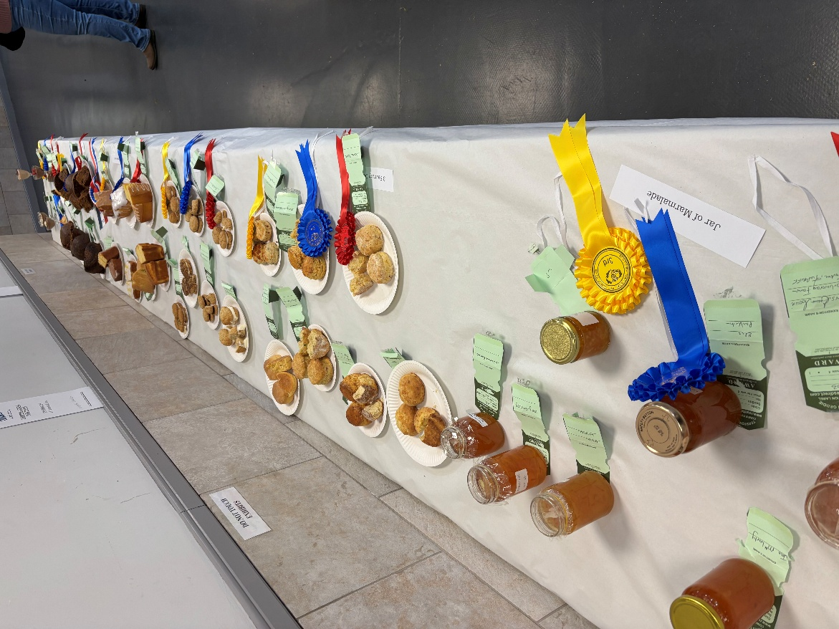
Floral arrangement (Show Day)
1st – Jan Maclarty
2nd – Elizabeth Pinkerton
Jar of Marmalade
1st - Emma Cowie
2nd - Elizabeth Pinkerton
3rd - Lesley Hunter
3 Savoury Scones
1st - Susan Robb
2nd - Mary Armstrong
3rd - Lesley Hunter
3 Gypsy Creams
1st - Elizabeth Pinkerton
2nd - Lesley Hunter
3rd - Jan Maclarty
1lb Lemon Loaf
1st - Susan Robb
2nd - Emma Cowie
3rd - Lesley Hunter
Microwave Dumpling
1st - Elizabeth Pinkerton
2nd - Jan Maclarty
3rd - Mary Armstrong
2 choux filled buns
1st - Susan Robb
2nd - Mary Armstrong
Chocolate Mousse
1st - Jan Maclarty
2nd - Lesley Hunter
3rd - Elizabeth Pinkerton
Plate tart
1st - Jan Maclarty
2nd - Lesley Hunter
3rd - Mary Armstrong
Bottle infused alcohol
1st - Elizabeth Pinkerton
2nd - Amy Henderson
3rd - Mary Armstrong
Something new from Something old
1st - Elizabeth Pinkerton
2nd - Jan Maclarty
3rd - Emma Cowie
Gift wrapped parcel
1st - Lesley Hunter
2nd - Mary Armstrong
3rd - Jan Maclarty
Mens class favourite filled sandwich
1st - Cameron Armstrong
2nd - Andrew Pinkerton
3rd - Robert Robb
5 & under
Decorated welly
1st - Jack Smith
2nd - Finlay Henderson
6- 10 years
Rossette made from sweets
1st - Steven Smith Jnr
Decorated welly
1st – Taylor Henderson

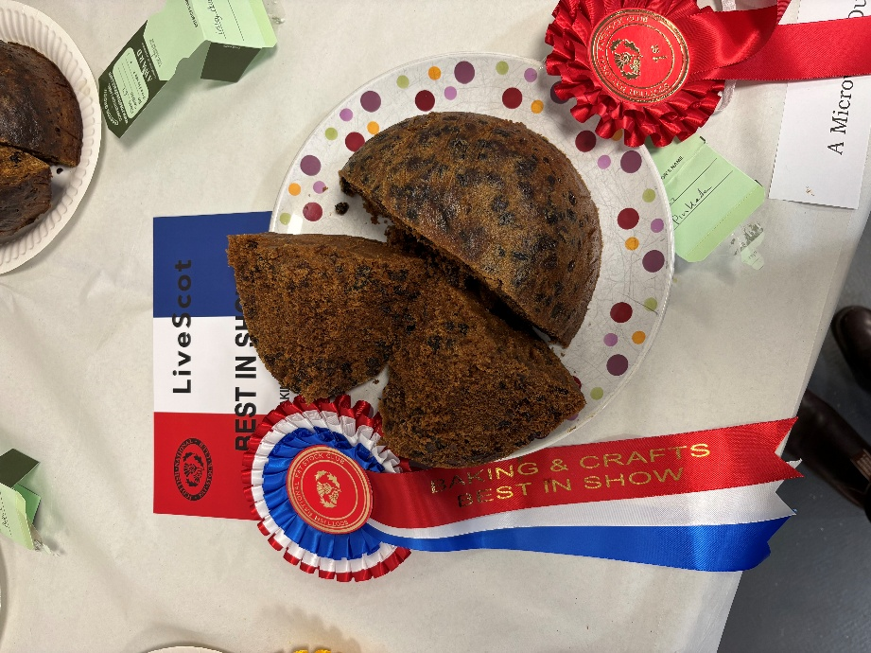

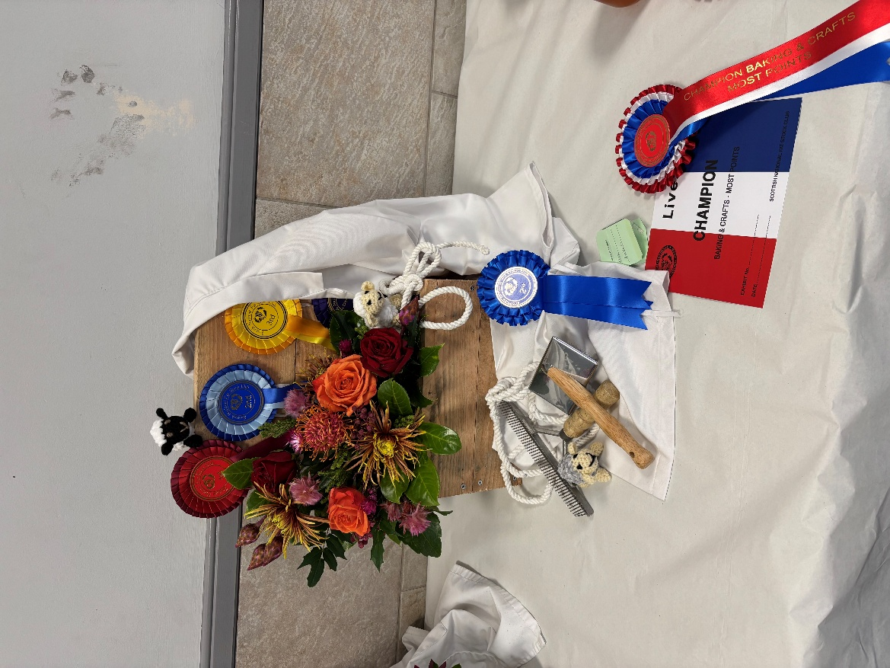
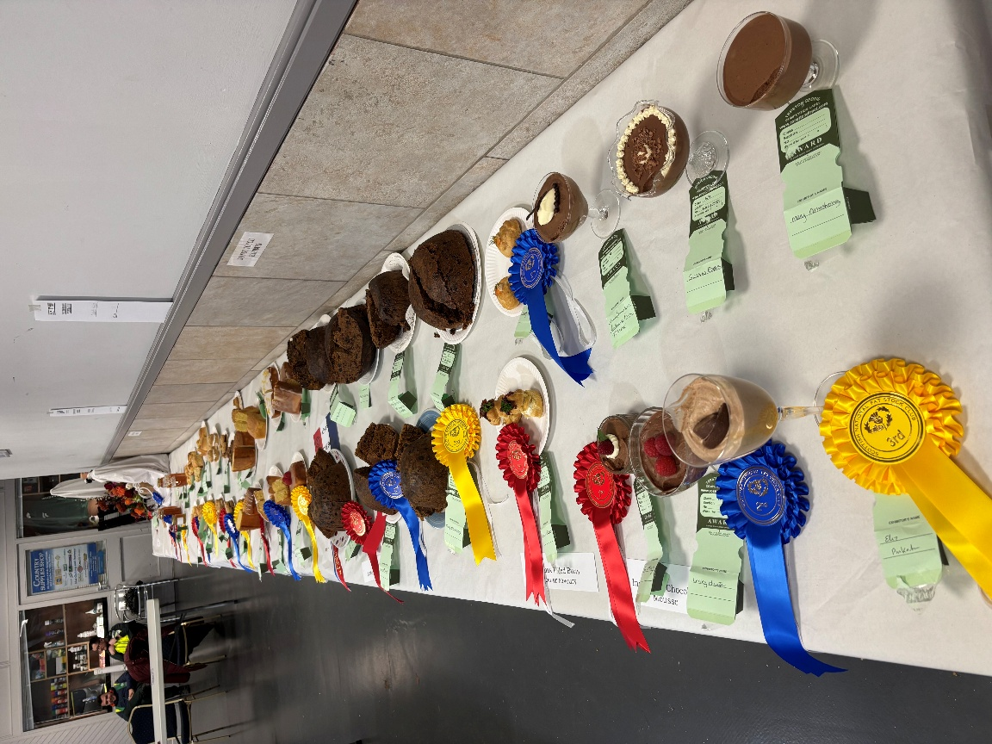

CROOKS
Class 50 Horn Crook (Plain or fancy)
1st – Murray Playfair
2nd – Iain Paterson
3rd – Eddy Forster

Class 51 Wooden Crook (Plain or fancy)
1st – Eddy Forster
2nd – Eddy Forster
3rd – Cliff Worrell

Class 52 Plain Horn Stick
1st – Murray Playfair
2nd – Murray Playfair
3rd – David Bowman

Class 53 Fancy Horn Stick
1st – Ian McConchie
2nd – Eddy Forster
3rd – Iain Paterson

Class 54 Plain Wood Stick
1st – Cliff Worrell
2nd – Iain Paterson
3rd – Murray Playfair

Class 55 Fancy Wood Stick
1st – Eddy Forster
2nd – Barry Frizell
3rd – Cliff Worrell

Class 56 Leg Cleek
1st – Cliff Worrell
2nd – Richard Russell
3rd – Jake Bryce

Class 57 Thumb Stick
1st – Richard Russell
2nd – Cliff Worrell
3rd – Eddy Forster

Class 58 Sportsman Stick
1st – Cliff Worrell
2nd – Eddy Forster
3rd – Arthur Dent

Class 59 Buffalo Horn stick Plain or Fancy
1st – Iain Paterson
2nd – Eddy Forster
3rd – Richard Russell

Class 60 Novice – Any Stick –Horn
1st – David Bowman
2nd – Nick Day
3rd – Sandy Patterson

Class 61 Novice – Any Stick –Wood
1st – John Reidy
2nd – Carole Angus
3rd – John Reidy

CHAMPION STICK: Ian McConchie
RESERVE: Murray Playfair
NOVICE CHAMPION: David Bowman
RESERVE: John Reidy

NATIVE PONY WINTER FAIR

HIIGHLAND PONIES

Class 81 Filly Foal

1st - Lynn & Lynn Paisley - Learigg Aven May

Class 83 Yearling Filly, Colt or Gelding

1st - Emma Hamilton - Aikengall Belhaven Boy

2nd - A & H Kerr- Tower Gabrielle

3rd - A & H Kerr - Tower Evensong

Class 86 Two or Three year old colt or gelding

1st - Miss Lauren Jarvis - Trailtrow Toradh

2nd - Brian Williams - Avongar Platinum

3rd - Scott Borthwick - Balhernoch Arran

Champion Highland Pony – Emma Hamilton - Aikengall Belhaven Boy

Reserve Champion Highland Pony – A & H Kerr- Tower Gabrielle
Best Highland Foal – Lynn & Lynn Paisley - Learigg Aven May

Best yearling – Emma Hamilton - Aikengall Belhaven Boy

SHETLAND PONIES

Class 87 Stallion or colt 2 years old or over
1st - Eynhallow Shetland Pony Stud - Harviestoun Drum

Class 88 Two or Three year old Filly or Gelding

1st - Charlotte Ferrie - Beeftub Cotton

2nd - John Watson - Abbotsrule Snowdrop

3rd – Eynhallow Shetland Pony Stud - Eynhallow Dutch Connie

Class 89 Yearling Colt, Filly or Gelding (class may be split if sufficient forward)

1st - John Watson - Abbotsrule Falcon

2nd - John Watson - Coltanford Dodger

3rd – John Watson - Millquoy Jimi O'the Mill

Class 90 Colt or Filly Foal (class may be split if sufficient forward)

1st - Eynhallow Shetland Pony Stud - Eynhallow Strom

2nd - John Watson - Abbotsrule Syke

3rd – Erin Cantley - Kellinda Nutcracker

Class 91 Mares, 4 years old and over

1st - Eynhallow Shetland Pony Stud - Eynhallow Contessa

Class 92 Gelding four years and over

1st - Miss Lauren Jarvis - Laddyll Serenity

2nd - Sarah Paterson - Buxted Mr Nice Guy

Class 94 Miniature Stallion or gelding 4 years old and over

1st - Robert S Pitcairn - Halstock Lorenzo

2nd - Andy Thornley - Alichbrae Bruno

Class 95 Miniature 2 or 3 years old filly colt or gelding

1st - Susan Cook - Shallochmill Charlotte

2nd - Nicola Hair - Shallochmill Nikki

3rd - Karen Scott- Robins Brae Delight

Class 96 Miniature 1 year old filly colt or gelding

1st - Andy Thornley - Robin's Brae Fluer

2nd - Karen Scott - Ferinfield Houdini

3rd - Susan Cook - Shallochmill Tutti Frutti

Class 97 Miniature Colt or filly foal

1st - Susan Cook - Shallochmill Ruadh

2nd - Nicola Hair - Bitigrai Little Miss Show Off

Class 98 Young handler
1st - Charlotte Ferrie
2nd - Paul Jarvis
3rd - Leah Jarvis

Best young handler – Charlotte Ferrie
Champion Shetland Pony – Eynhallow Shetland Pony Stud - Harviestoun Drum
Reserve Champion – Charlotte Ferrie - Beeftub Cotton
Best Miniature – Andy Thornley - Robin's Brae Dakota
Reserve miniature – Robert S Pitcairn - Halstock Lorenzo
Best Foal – Eynhallow Shetland Pony Stud - Eynhallow Stroma

LANARKSHIRE YOUNG FARMERS CALF RALLY

Overall Champion - Clare Miller
Overall Reserve Champion - Erin Purdon
Female Champion - Clare Miller
Male Champion - Erin Purdon
Best Weight Gain - Cameron Orr (478KG)
Most profit - Cameron Orr
Best stockman - Ben Graham
Best stockwoman - Clare Miller

Class 1 Heifers 582KG - 640KG
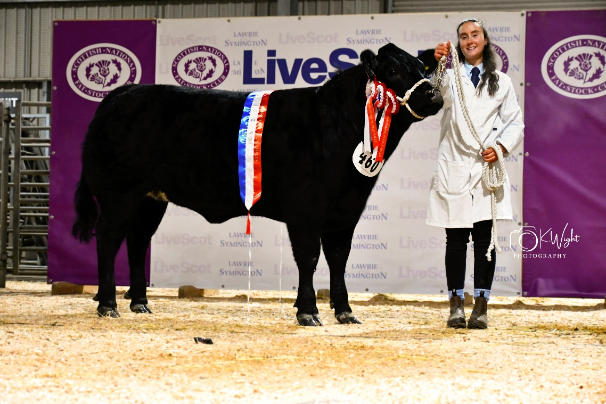
1st - Amy MacLarty
2nd - Ruth Haddow
3rd - Karen Miller

Class 2 Bullocks 588KG - 672KG
1st - Jane Lindsay
2nd - Ross Comrie
3rd - Ben Baillie

Class 3 Heifers 640KG - 676KG
1st - Clare Miller
2nd - Amy MacLarty
3rd - Vicky Haddow

Class 4 Bullocks 695KG - 725KG
1st - Erin Purdon
2nd - Cameron Armstrong
3rd - Vicky Haddow

Class 5 Heifers 660KG - 722KG
1st - Ruth Haddow
2nd - Cameron Armstrong
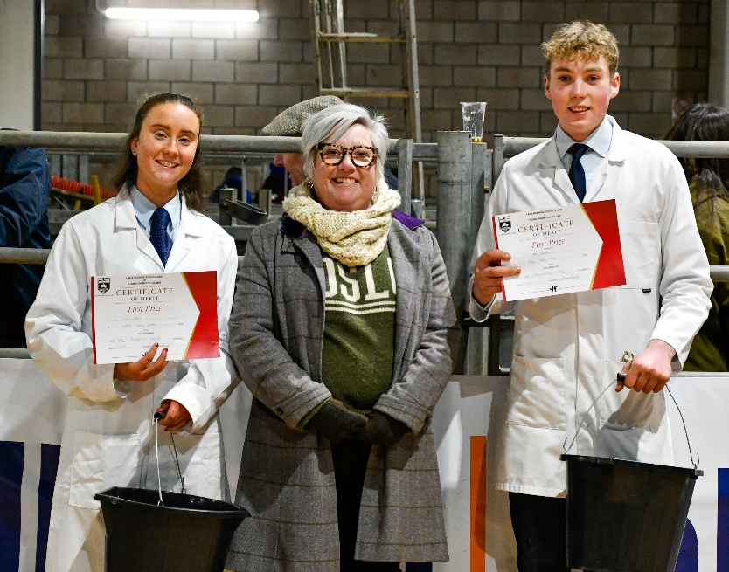
3rd - Erin Purdon

Class 6 Bullocks 730KG - 750KG
1st - Robbie Armstrong
2nd - Ben Graham
3rd - Lucy Graham

Class 7 Unhaltered Heifers
1st - Sarah Comrie
2nd - Cameron Armstrong
3rd - Cameron Orr

Class 8 Unhaltered Males
1st - Eilidh Armstrong
2nd - Cameron Armstrong
3rd - Clark Ferguson

